Project 1

I would say just about 190-195lbs

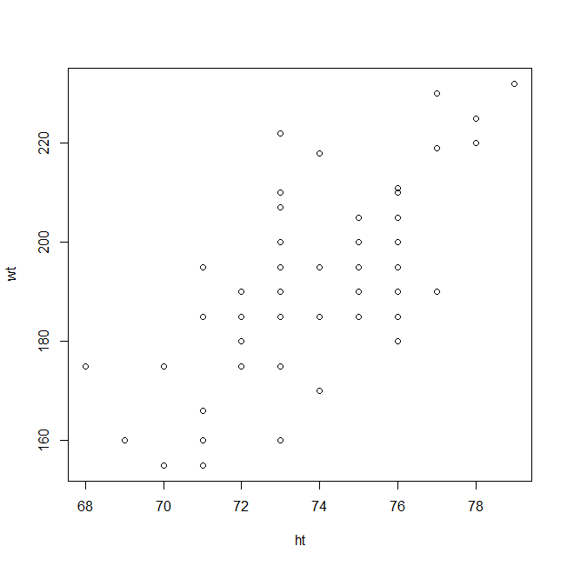1.

I would say just about 190-195lbs.

2. [1] 17 21 23 28 44

I’m not sure what I’m supposed to write about these 5 numbers, but I can say I fought R to get them. I couldn’t get the sourcing to work, so I input the function manually, and then called lotto147(). They seem to be fairly random. I think the sort() sorts them by value. It’s mostly random, except for that they’re sorted, and I don’t think duplicates are allowed. I’m not sure on that.

I hope that satisfies.